

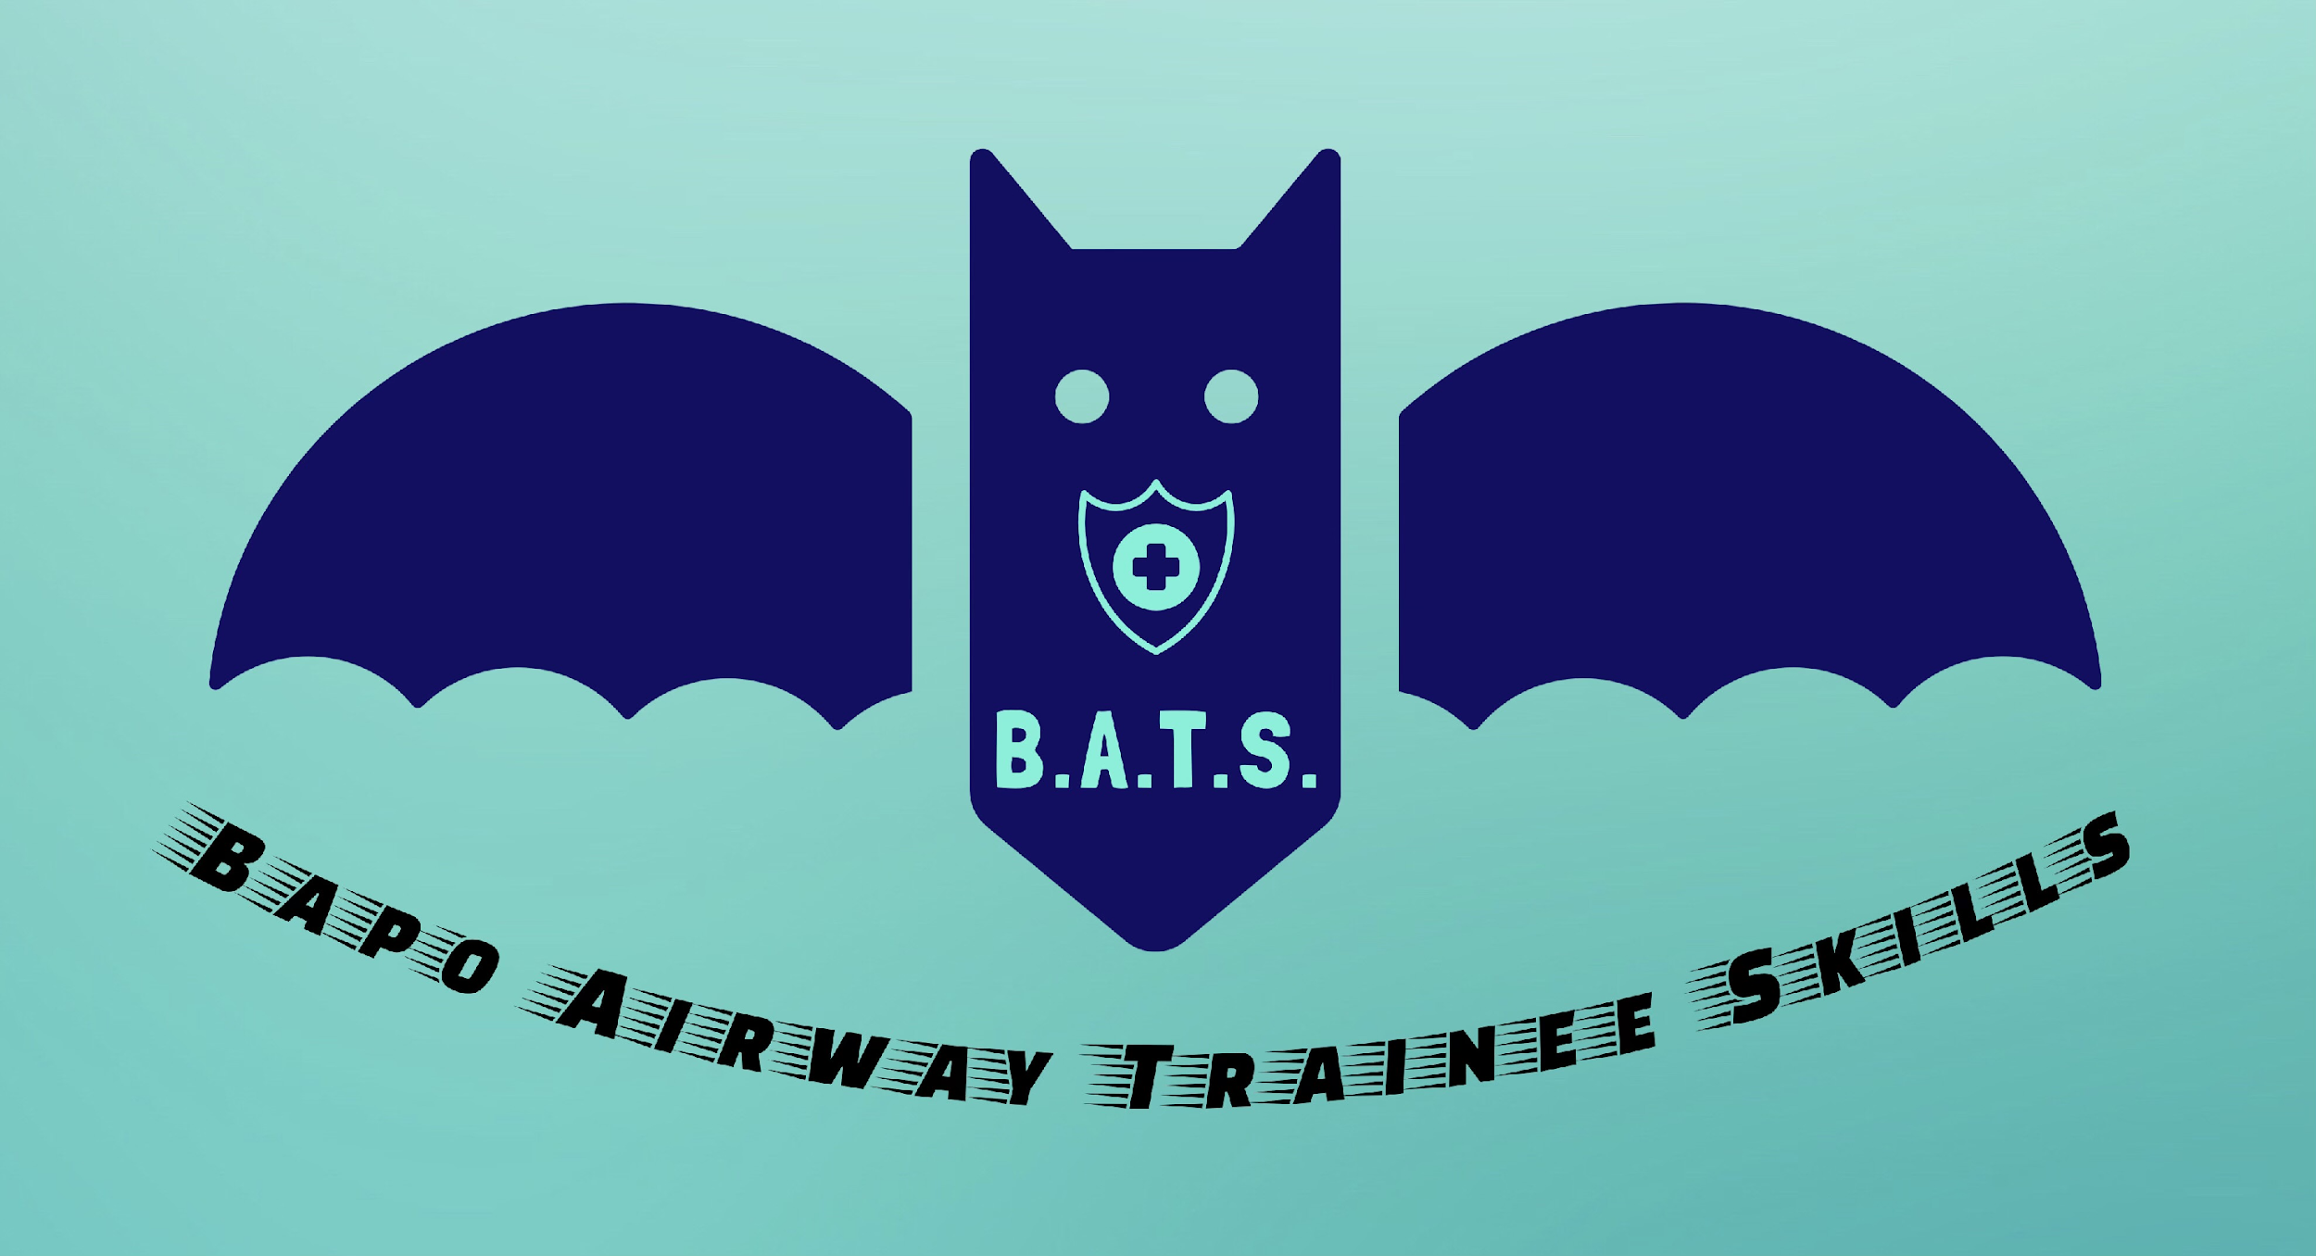

BRITISH ASSOCIATION FOR PAEDIATRIC OTOLARYNGOLOGY
AIRWAY TRAINEE SKILLS COURSE
(Course Plan -faculty)

Friday 10th July 2026

Venue: KARL STORZ Training and Technology Centre, 415 Perth Avenue, Slough, Berkshire UK SL1 4TQ

Time | Location | Activity | Facilitators
08:30 |  | Coffee & Registration
09.00 |  | Welcome | Hasnaa Ismail-Koch
09.10 |  | Concept and aims
09.20  09:25  09:35  09:50  10:05 |  | Management of upper airway obstruction  - Medical  -Anaesthetic  - ENT  Retrieval | Andy Hall
10:10 |  | Carer Experience | Nic Hughes
10:30 |  | Coffee
 |  | In rotation | Station Leads & Faculty
11:00 |  | Bronchoscopy & Foreign body retrieval
11.40 |  | Tracheostomy
12:20 |  | ENT Intubation & Difficult Intubation
12:40 |  | Blocked Tracheostomy
13:00 |  | Lunch
 |  | In Rotation
14:00 |  | Scenario 1-3 | See below
14:40 |  | Scenario 1-3 | See below
15:20 |  | Coffee
15:40 |  | Scenarios 1-3 | See below
16:20 |  | Conclusions & Feedback | Hasnaa, Andy, Ravi
16:40 |  | Close

 | Bronchoscopy & FB Removal | Tracheostomy | ENT Intubation | Blocked Tracheostomy
Group 1 | 11:00-11:40 | 11:40-12:20 | 12:20-12:40 | 12:40-13:00
Group 2 | 11:40-12:20 | 12:20-13:00 | 11:00-11:20 | 11:20-11:40
Group 3 | 12:20-13:00 | 11:00-11:40 | 11:40-12:00 | 12:00-12:20

 | Scenario 1 (difficult Intubation) | Scenario 2  (Can’t intubate/ ventilate) | Scenario 3  (Craniofacial /upper airway)
Group 1 | 14:00-14:40 | 14:40-15:20 | 15:40-16:20
Group 2 | 14:40-15:20 | 15:40-16:20 | 14:00-14:40
Group 3 | 15:40-16:20 | 14:00-14:40 | 14:40-15:20

Scenario Leads & Faculty:
Scenario 1:
Scenario 2:
Scenario 3:

